|  |  |
| --- | --- |
| *Name* | *Handbag* |
| *Color* | ***Black*** |
| *Size* | ***5 inch*** |
| *Brand* | ***31 Philliplim*** |
| *Price* | ***PKR 300*** |

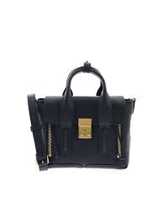

|  |  |
| --- | --- |
| *Name* | *Handbag* |
| *Color* | ***White*** |
| *Size* | ***4 inch*** |
| *Brand* | ***31 Philliplim*** |
| *Price* | ***PKR 350*** |

|  |  |
| --- | --- |
| *Name* | *Handbag* |
| *Color* | ***Brown*** |
| *Size* | ***7 inch*** |
| *Brand* | ***31 Philliplim*** |
| *Price* | ***PKR 350*** |

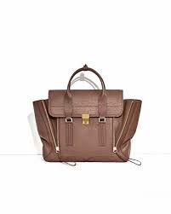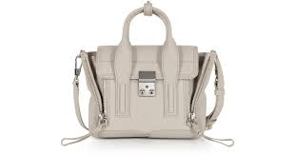

|  |  |
| --- | --- |
| *Name* | *Handbag* |
| *Color* | ***White*** |
| *Size* | ***2.7 inch*** |
| *Brand* | ***31 Philliplim*** |
| *Price* | ***PKR 350*** |

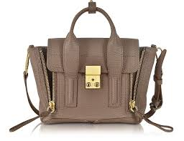

|  |  |
| --- | --- |
| *Name* | *Handbag* |
| *Color* | ***Light Brown*** |
| *Size* | ***4 inch*** |
| *Brand* | ***31 Philliplim*** |
| *Price* | ***PKR 3500*** |

|  |  |
| --- | --- |
| *Name* | *Handbag* |
| *Color* | ***Brown*** |
| *Size* | ***8 inch*** |
| *Brand* | ***31 Philliplim*** |
| *Price* | ***PKR 350*** |

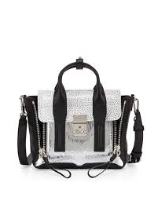

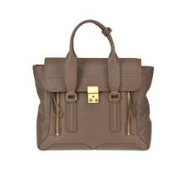

|  |  |
| --- | --- |
| *Name* | *Handbag* |
| *Color* | ***Blue*** |
| *Size* | ***2.7 inch*** |
| *Brand* | ***31 Philliplim*** |
| *Price* | ***PKR 350*** |

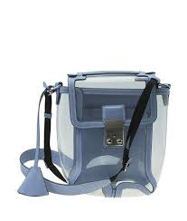

|  |  |
| --- | --- |
| *Name* | *Handbag* |
| *Color* | ***Light Green*** |
| *Size* | ***6 inch*** |
| *Brand* | ***31 Philliplim*** |
| *Price* | ***PKR 350*** |

|  |  |
| --- | --- |
| *Name* | *Handbag* |
| *Color* | ***Red*** |
| *Size* | ***2.7 inch*** |
| *Brand* | ***31 Philliplim*** |
| *Price* | ***PKR 350*** |

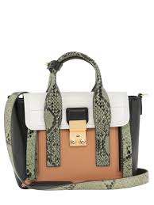

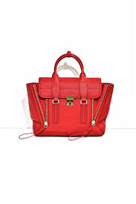

|  |  |
| --- | --- |
| *Name* | *Handbag* |
| *Color* | ***Grey*** |
| *Size* | ***2.7 inch*** |
| *Brand* | ***31 Philliplim*** |
| *Price* | ***PKR 350*** |

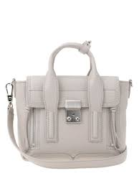

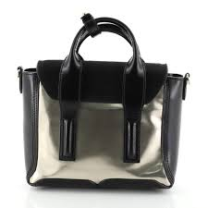

|  |  |
| --- | --- |
| *Name* | *Handbag* |
| *Color* | ***Silver*** |
| *Size* | ***2.7 inch*** |
| *Brand* | ***31 Philliplim*** |
| *Price* | ***PKR 350*** |

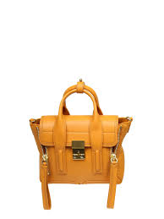

|  |  |
| --- | --- |
| *Name* | *Handbag* |
| *Color* | ***Orange*** |
| *Size* | ***2.7 inch*** |
| *Brand* | ***31 Philliplim*** |
| *Price* | ***PKR 350*** |